# Question I

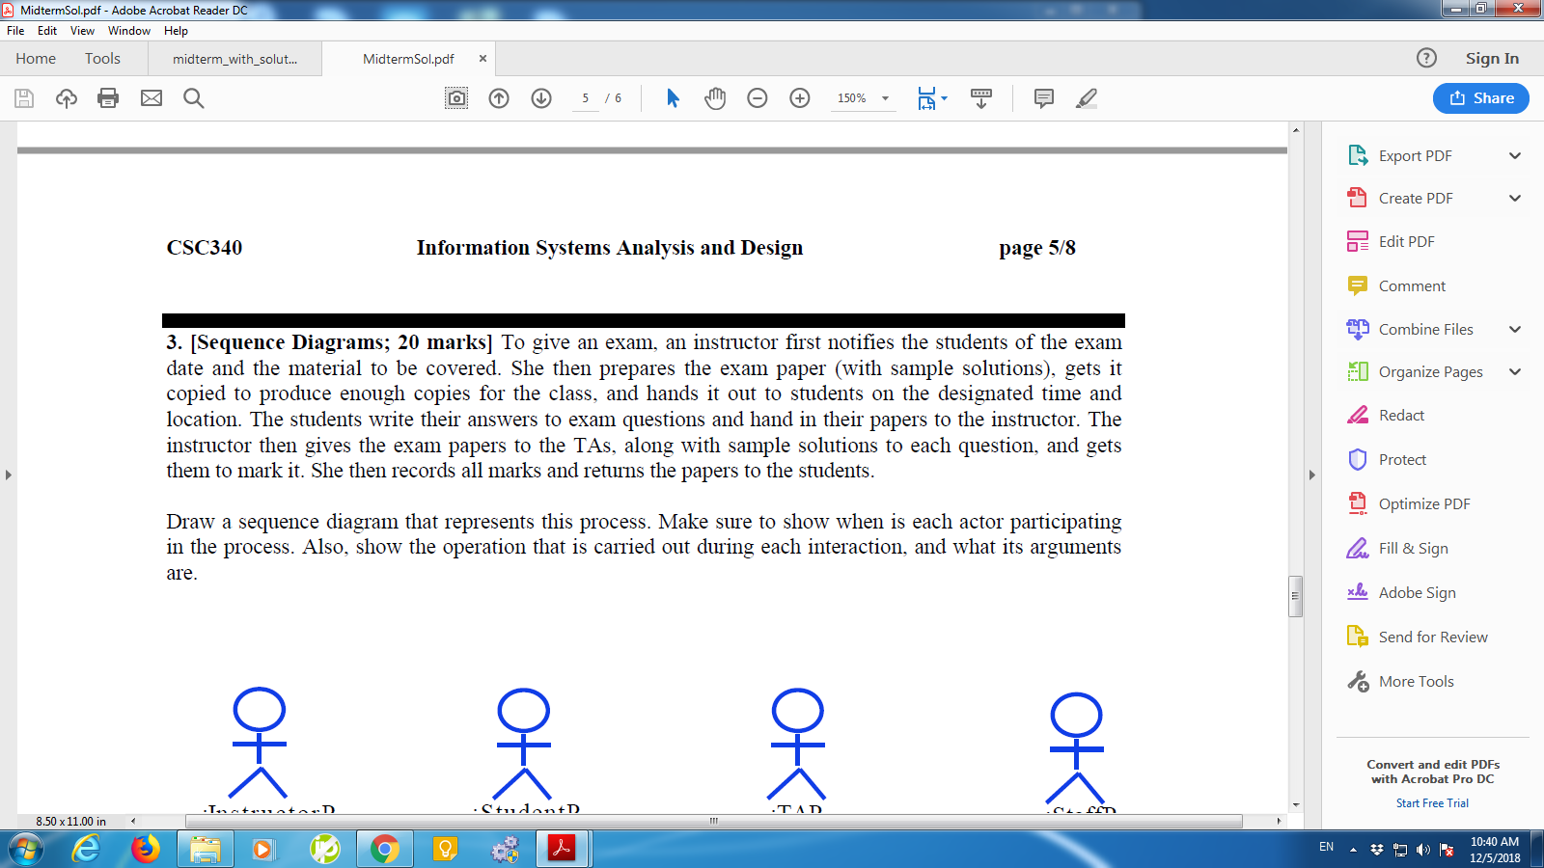

# Question II

Extract the class diagram corresponding to the following sequence diagram.

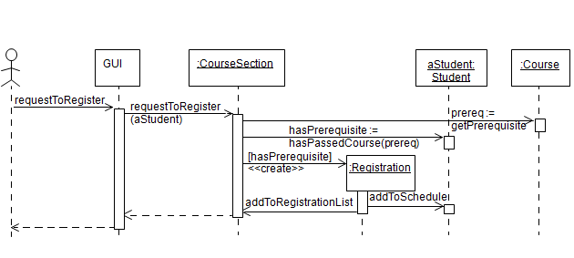

# Question III

Extract the class diagram corresponding to the following sequence diagram.

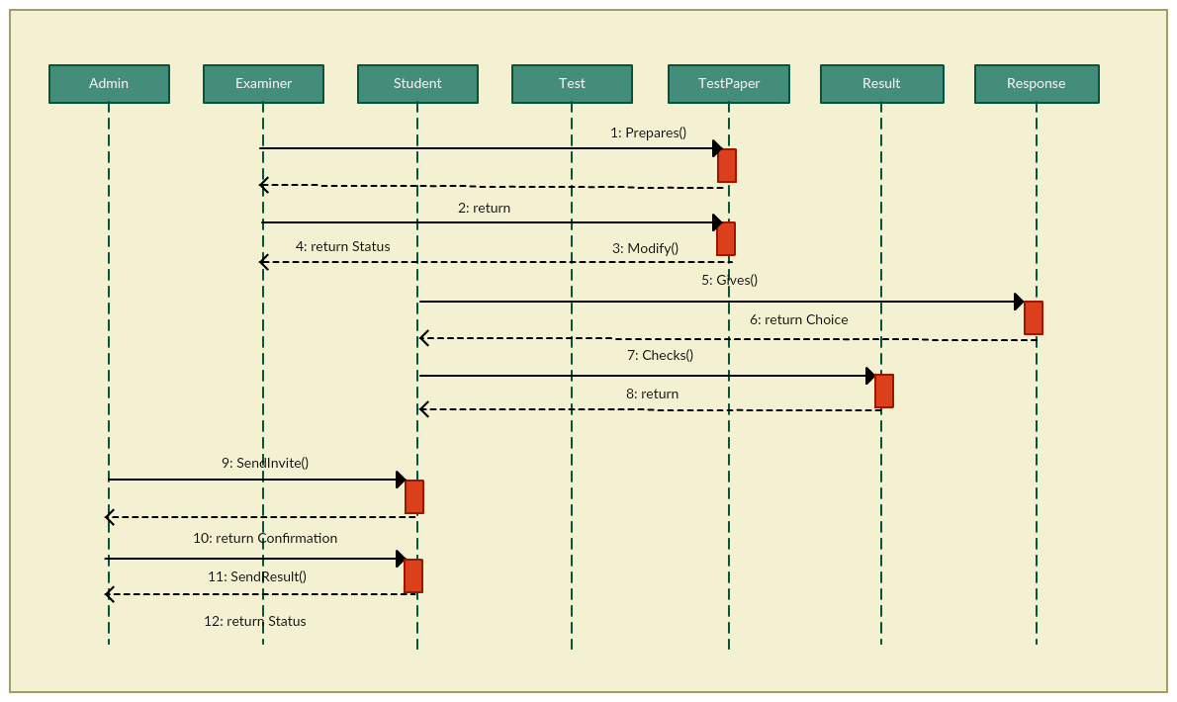

# Question IV

 Name the four numbered elements in this diagram:

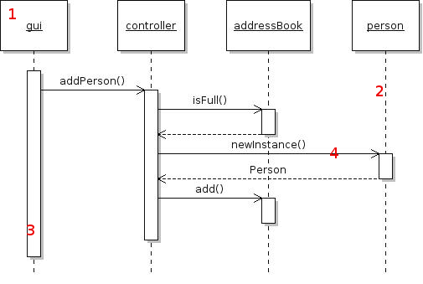

# Question V

Identify the errors in notation in this diagram:

